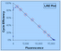

LRE Analyzer Quick Start (Version 0.9)

Overview
The LRE Analyzer was developed as a standalone, platform independent desktop program that enables large-scale absolute quantification by eliminating the need to construct target-specific standard curves. LRE qPCR also provides a number of quality control capabilities not possible with conventional real-time qPCR. Along with improvements in data display and storage, this version of the LRE Analyzer implements nonlinear regression analysis that improves both the robustness and accuracy of absolute qPCR.

Among the many advantages of absolute quantification, the universal perspective it provides allows quantitative data derived from diverse sources, such as from different assays, instruments and/or research groups, to be directly compared without the need for some form of normalization. Furthermore, absolute quantification has important implications for gene expression profiling, in that it allows transcript quantities produced by any gene to be directly compared to any other gene, within and between multiple samples, again without the need for normalization.

Many of these attributes were illustrated in a recent study that used the LRE Analyzer for expression analysis of 17 genes within 38 samples, which revealed, among other insights, that the magnitude of gene expression can vary over at least five magnitudes (Rutledge et al. 2013).

Installation
The LRE Analyzer is a Java program that does not require any administrator privileges for installation. Simply unzip the LRE Analyzer folder (lreanalyzer09X) to a convenient location, go into the “bin” directory and start the program by double clicking the lreanalyzer09X.exe file. For greater convenience, a shortcut can be created (Windows: Alt + drag). The only requirement is that Java SE7 be installed.

The program has been extensively tested on Windows XP, and has been found to function under UNIX. However, note that Apple only supports Java SE on 64-bit capable Intel-based Macs running OS X 10.6 and 10.5. The most current updates for 10.5 and 10.6 can be found here:
http://support.apple.com/kb/DL1359
http://support.apple.com/kb/DL1573

1) Adjust the panels
When first started, the program will display three rather large panels. Reduce their size by first iconizing the two right hand panels by clicking on the square located on the top right. Reduce the size of the program window by dragging the bottom right corner, in addition to dragging the left hand divider:

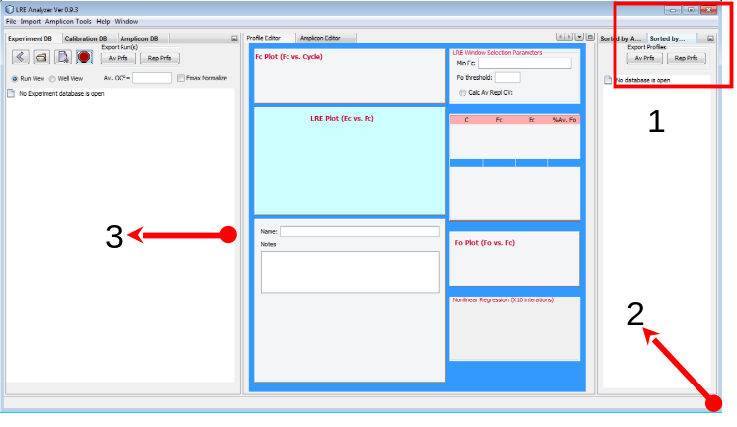 | 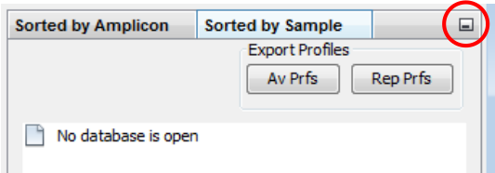

This leaves the explorer and editor panels, with the sorting panels displayed as buttons on the right hand border. Note that these changes are saved when the program is closed, so that when restarted the program will retain the same configuration.

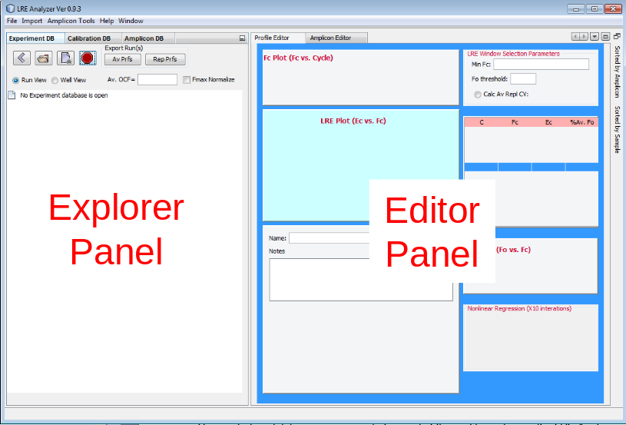

2) Load the demonstration experiment database
Demonstration databases were provided as part of the zip file containing the LRE Analyzer program. The four buttons in the top left hand corner of the explorer panel allow experiment databases to be opened, closed or created:

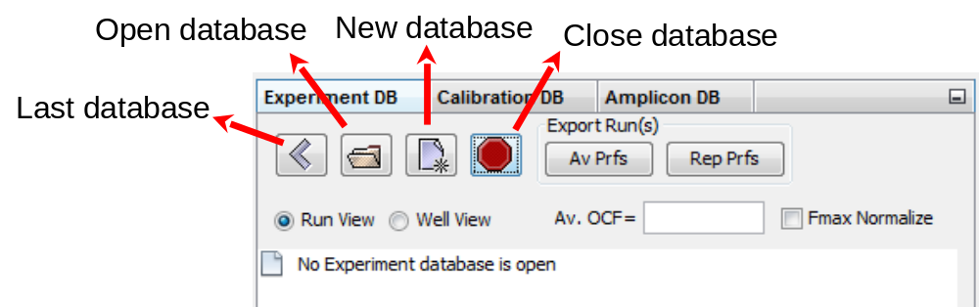

Click on the open database button, navigate to directory where the demonstration databases were unzipped and select “LRE Experiment Demo Database Ver 0.9.exp”. The explorer panel should then display a tree listing the three replicate runs stored within this database:

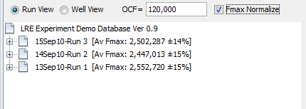

Clicking on the plus icon beside a run will open it to display all of the amplification profiles within the run, which in this case are transcript quantifications of four reference genes within three replicate reverse transcriptase reactions (COL1-3). Each label consists of “amplicon name” @ “sample name” (amplification efficiency) N= number of transcript molecules:

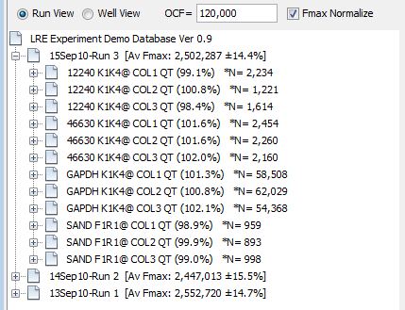

Clicking on a profile will display all of the data associated with that profile within the editor window:

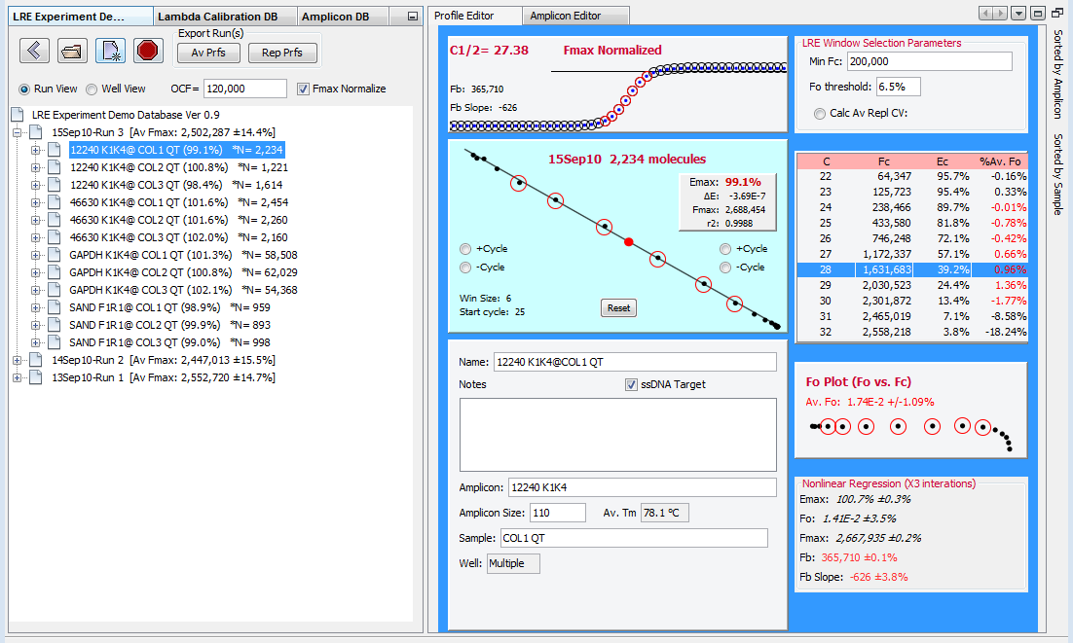

Although a large amount of information is presented, the most important is the LRE Plot that displays the linear regression used for kinetic analysis, from which amplification efficiency (E_{max}) and target quantity are derived (see below for more details as to how target quantity is determined):

Linear Regression of Efficiency (LRE) Plot
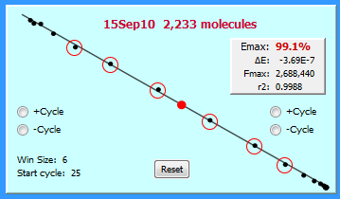

3) Sorting data for viewing and export
Although data can be exported in a run-based format, the sorting panels located on the far right border can be used to organize the data either by amplicon or sample. Hovering the mouse over their buttons will cause a panel to fly out, which in this example lists the four reference gene amplicons, along with their average amplification efficiency and CV generated by all of the profiles within the database produced by each amplicon:

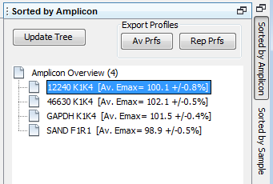

Selecting an amplicon will trigger the Explorer Panel to list all of the profiles produced by that amplicon:

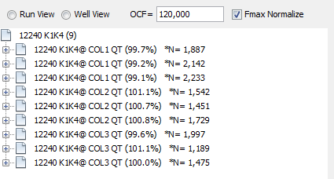

In this case, the nine profiles produced by the 12240 K1K4 amplicon are displayed, along with their respective amplification efficiencies and the number of transcript molecules, within each of three replicate reverse transcriptase reactions (COL1-3) that were quantified across the three replicate runs.

This illustrates the central utility of this list, which is the ability to examine data generated over multiple runs that for this example, allows run-to-run variance to be assessed (average of about ±7%). Note also that Col1-3 are cDNA preparations generated from the same RNA sample, which allows the variance of reverse transcription to also be evaluated (average of about ±9%).

These sorted lists also allow data to be exported either by amplicon or sample, allowing data generated across multiple runs to be exported as a group into a MS Excel worksheet. Selecting multiple amplicons (e.g. Windows: Ctrl + left click) generates a worksheet for each amplicon:

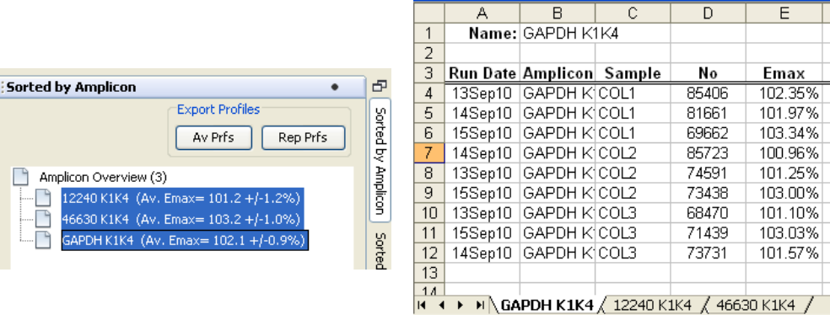

Thus, the sorting panels not only allow viewing and editing of data generated across multiple runs, they also allow large amounts of data to be exported in an organized fashion.

Note that the program’s help documentation provides extensive information about how the program functions, including the optical calibration and amplicon database windows not discussed here, in addition to guidelines on how to monitor assay performance and assess quantitative accuracy.

Importing qPCR data
Founded on kinetic analysis of SYBR Green I fluorescence readings generated by real-time qPCR, LRE qPCR can be applied to any qPCR instrument that allows fluorescence readings to be exported. The LRE Analyzer provides the ability to import data from a number of instruments, although the simplest method is to manually import data using the Excel templates provided within the program. However, before attempting to analyze your own datasets, it is recommended that the “Implementing LRE-based Assays” overview within the program’s help be consulted.

It is also important to understand that a new experiment database should be created for each assay-instrument combination, in order to facilitate the optical calibration required for absolute quantification. As described below, this is generally achieved using a quantitative standard, although it is possible to conduct a crude optical calibration based on the average height of the profiles within a run.

A brief overview of how LRE qPCR functions
This overview is intended to only provide a basic understanding of how LRE-based quantification is achieved. Detailed descriptions of how LRE qPCR was developed and tested have been published (Rutledge & Stewart 2008a; Rutledge & Stewart 2008b; Rutledge & Stewart 2010), in addition to a three part video series available within the LRE qPCR website (https://sites.google.com/site/lreqpcr/home).

Derived from adapting the classic Boltzmann sigmoidal function to model PCR amplification, the following equation allows the fluorescent readings within the central region of an amplification profile (F_{C}) to be converted into target quantity expressed in fluorescence units (F₀), based on cycle number (C), the height of the profile (F_{max}), and amplification efficiency (E_{max}):
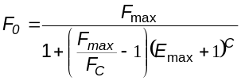

This generates 3-8 determinations from each individual amplification profile, which are displayed within the F₀ Plot:

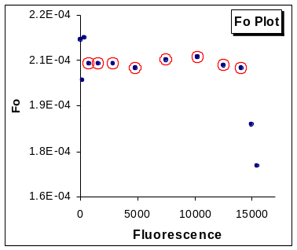
These F₀ values are averaged and converted into DNA mass (M₀) using an optical calibration factor (OCF: fluorescence units per ng) derived by amplification of a known quantity of lambda genomic DNA, an approach loosely analogous to that used for quantification of nucleic acids using a fluorescent dye. DNA mass is then converted into the number of target molecules (N₀) based on amplicon size (A_{s}):

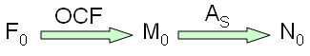

The key attribute of this approach is that absolute quantification can be conducted without construction of target-specific standard curves. However, it is necessary to manually enter an OCF value into the experiment explorer window, which is then used by the program to convert the average F₀ values for all of the profiles within the experiment database. Note, however, that a run-specific OCF can also be entered by right-clicking a run.

Although the ubiquitous nature of lambda gDNA makes it an attractive choice for optical calibration, any DNA target of known quantity can be used to derive an OCF. For example, profiles from a standard curve can be used to determine an OCF by importing the profiles into a newly created experiment database, and repeatedly entering OCF values until correlation to the predicted target quantities are maximized.

An even simpler approach is to crudely estimate the OCF based on the average height of the profiles within a run, an approach derived from the empirical observation that 5% of a run’s average Fmax can generate a value similar to that produced with a quantitative standard. However, it is recommended that this approach be only used for assessing the functionality of the LRE Analyzer, as absolute accuracy cannot be assured. Refer to the help documentation for additional information.

Ongoing work has also demonstrated that other methods, such as using genomic DNA from your target species as a quantitative standard, or profiles generated from a single target molecule, can also be used for optical calibration, which has provided support for the general efficacy of conducting absolute quantification in this fashion. Furthermore, the performance of LRE qPCR has been extensively tested, demonstrating that quantitative accuracies of ±20-25% can be routinely achieved, along with the ability to accurately quantify a single target molecule.

Much of this work is described within a three part video series outlining how LRE qPCR was conceived and tested, which are available within the LRE qPCR website (https://sites.google.com/site/lreqpcr/home). Rutledge et al. (2013) also provides an example of large-scale gene expression profiling using the LRE Analyzer, which included analysis of nine reference genes.

References
Rutledge, R.G. & Stewart, D., 2008a. A kinetic-based sigmoidal model for the polymerase chain reaction and its application to high-capacity absolute quantitative real-time PCR. BMC Biotechnology 8, 47.
Rutledge, R.G. & Stewart, D., 2008b. Critical evaluation of methods used to determine amplification efficiency refutes the exponential character of real-time PCR. BMC Molecular Biology 9, 96.
Rutledge, R.G. & Stewart, D., 2010. Assessing the Performance Capabilities of LRE-Based Assays for Absolute Quantitative Real-Time PCR. PLoS ONE, 5 e9731.
Rutledge, R.G., 2011. A Java Program for LRE-based Real-time qPCR that Enables Large-Scale Absolute Quantification PLoS ONE 6, e17636.
Rutledge RG, Stewart D, Caron S, Overton C, Boyle B, MacKay J, Klimaszewska K. 2013. Potential link between biotic defense activation and recalcitrance to induction of somatic embryogenesis in shoot primordia from adult trees of white spruce (Picea glauca). BMC Plant Biology 13, 116

